Name: Richard Raymond J. Canda

C.Y.S.: BSCpE - 3A

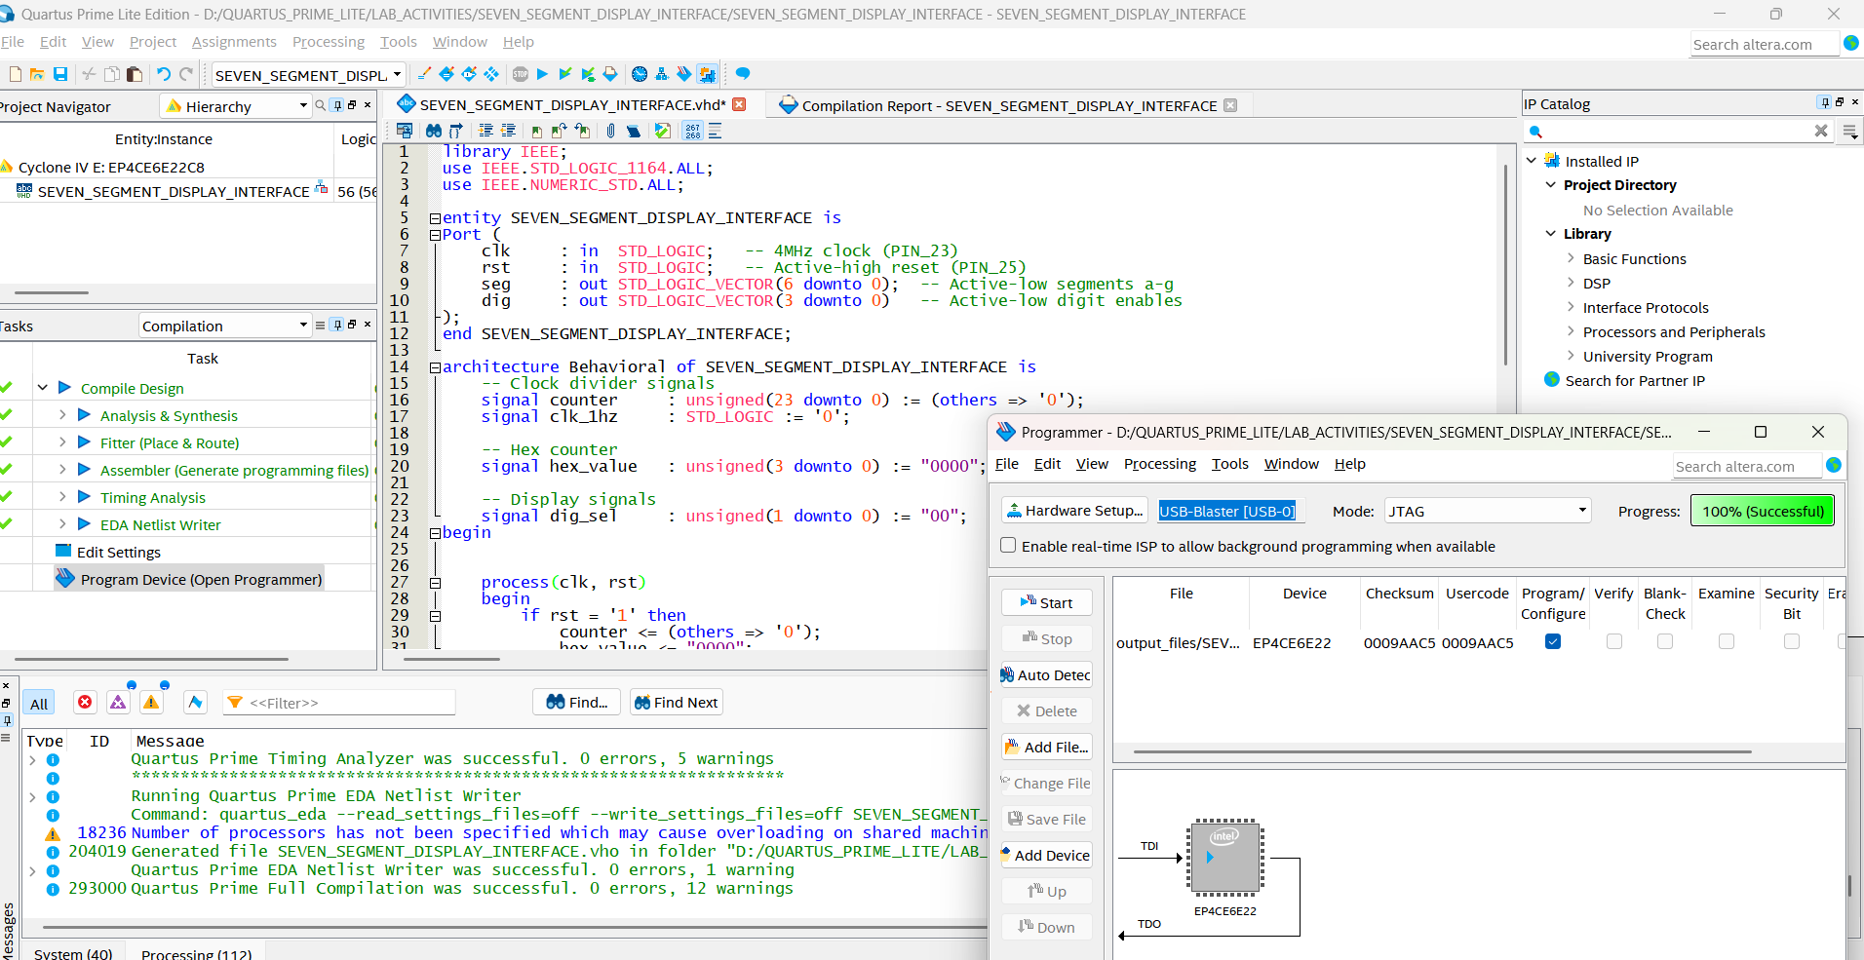

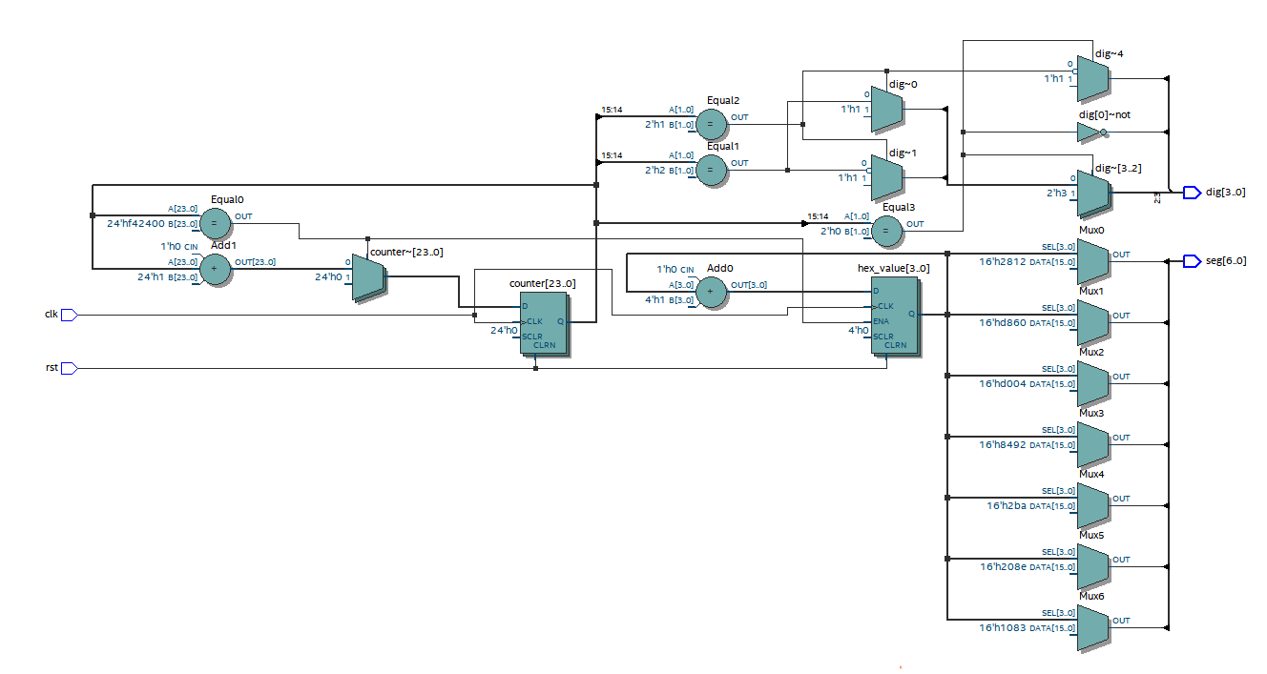

**VHDL CODE FOR SEVEN SEGMENT DISPLAY INTERFACE**

library IEEE;

use IEEE.STD_LOGIC_1164.ALL;

use IEEE.NUMERIC_STD.ALL;

entity SEVEN_SEGMENT_DISPLAY_INTERFACE is

Port (

clk : in STD_LOGIC; -- 4MHz clock (PIN_23)

rst : in STD_LOGIC; -- Active-high reset (PIN_25)

seg : out STD_LOGIC_VECTOR(6 downto 0); -- Active-low segments a-g

dig : out STD_LOGIC_VECTOR(3 downto 0) -- Active-low digit enables

);

end SEVEN_SEGMENT_DISPLAY_INTERFACE;

architecture Behavioral of SEVEN_SEGMENT_DISPLAY_INTERFACE is

-- Clock divider signals

signal counter : unsigned(23 downto 0) := (others => '0');

signal clk_1hz : STD_LOGIC := '0';

-- Hex counter

signal hex_value : unsigned(3 downto 0) := "0000";

-- Display signals

signal dig_sel : unsigned(1 downto 0) := "00";

begin

process(clk, rst)

begin

if rst = '1' then

counter <= (others => '0');

hex_value <= "0000";

elsif rising_edge(clk) then

if counter = x"F42400" then -- 0.25Hz (4 seconds per count)

counter <= (others => '0');

hex_value <= hex_value + 1;

else

counter <= counter + 1;

end if;

end if;

end process;

-- Digit scanner (244Hz refresh)

dig_sel <= counter(15 downto 14); -- 4MHz/2^16 = ~244Hz

-- Single-digit display (all digits show same value)

dig <= "1110" when dig_sel = "00" else -- DIG1

"1101" when dig_sel = "01" else -- DIG2

"1011" when dig_sel = "10" else -- DIG3

"0111"; -- DIG4

-- Active-low hex decoder (common cathode)

with hex_value select

seg <= "0000001" when x"0", -- 0

"1001111" when x"1", -- 1

"0010010" when x"2", -- 2

"0000110" when x"3", -- 3

"1001100" when x"4", -- 4

"0100100" when x"5", -- 5

"0100000" when x"6", -- 6

"0001111" when x"7", -- 7

"0000000" when x"8", -- 8

"0000100" when x"9", -- 9

"0001000" when x"A", -- A

"1100000" when x"B", -- B

"0110001" when x"C", -- C

"1000010" when x"D", -- D

"0110000" when x"E", -- E

"0111000" when others; -- F

end Behavioral;